Amino Acid

* Contains an amino group and a carboxyl group attached to a single carbon atom (the α-carbon)
* The other two substituents of the α-carbon are a hydrogen atom and a R-group
* Amphoteric (with acidic carboxyl group and basic amino group) → can act as both acid and base

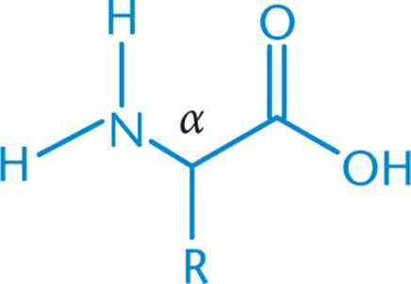

Peptide Bond

* Formation = condensation reaction
* Hydrolysis is catalyzed by a strong acid or base

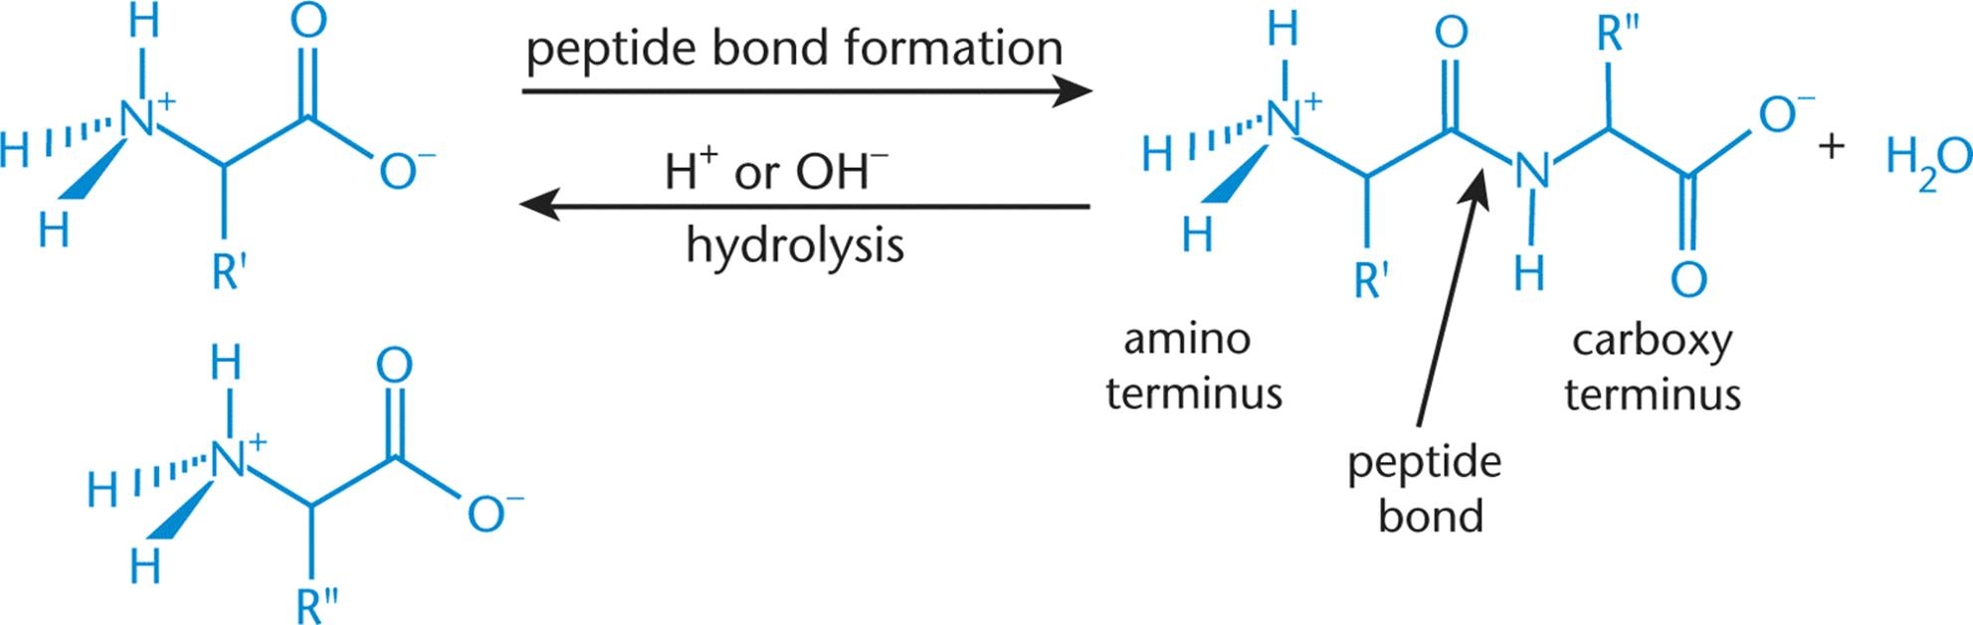

(Peptide Bond Formation and Cleavage)

* Resonance → gives the C-N bond a partial double-bond character → limits rotation around the peptide bond → rigidity and stability

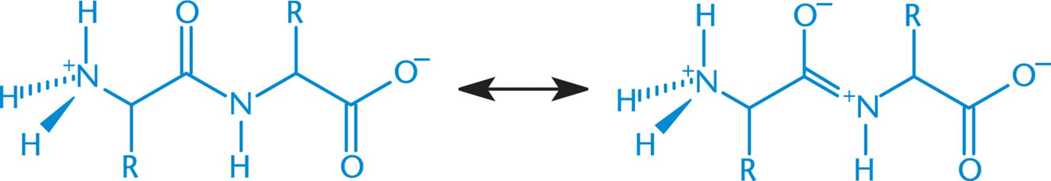

(Resonance in the peptide bond)

Synthesis of α-amino acids

1. Strecker Synthesis
   1. An aldehyde, NH4Cl, and KCN are used to make the aminonitrile; water is used to hydrolyze the aminonitrile to form the amino acid
   2. A condensation reaction (formation of an imine from a carbonyl-containing compound and ammonia, with loss of water), followed by nucleophilic addition (addition of the nitrile group), followed by hydrolysis
2. Gabriel Synthesis
   1. Begins with potassium phthalimide and diethyl bromomalonate, followed by an alkyl halide. Water is then used to hydrolyze the resulting compound to form the amino acid. While acids and bases are used at various times as catalysts, they are not the main reactants
   2. Proceeds through two SN2 reactions, hydrolysis, and decarboxylation

* Both synthesis methods start with a planar molecule, and therefore result in a racemic mixture of L- and D- amino acids

Phosphorus-Containing Compounds

* Phosphorus is found in **inorganic phosphate (Pi)**, a buffered mixture of hydrogen phosphate (HPO42-) and dihydrogen phosphate (H2PO4-)
* Phosphorus is found in the backbone of DNA, which uses phosphodiester bond
  + In forming these bonds, pyrophosphate **(PPi**, P2O74-) is released
  + Pyrophosphate can be hydrolyzed to two inorganic phosphate
* Phosphate bonds are high-energy because of:
  + Large negative charges in adjacent phosphate groups
  + Resonance stabilization of phosphates
* **Organic phosphates** are carbon-containing compounds that also have phosphate groups
  + E.g. Nucleotide triphosphates (e.g. ATP, GTP) and DNA
* Phosphoric acid has three hydrogens, each with a unique pKa
  + Wide variety in pKa allows phosphoric acid to act as a buffer over a large range of pH values